

BARCODE GENERATOR – MAGENTO 2

USER GUIDE

Table Of Contents

Preface ......................................…………………………………..…......3

Installation..….………………………………………………………………………..4

option1..............................................................................4
option2…………….................................................................6

Backend Example ……………………………………………………….....……...7

Extension configuration………………………………………………….……....7

Preface :

- A barcode system can help to make everything easier for the E-commerce business. Hence, Mageants has developed Barcode Generator for Magento 2 extension that allows creating barcode for products and print labels. The extension is all you need to create the barcode labels and print them in PDF format for the store products. By doing so, get the advantages of a barcode system like Manage the barcode labels for products. Save time significantly! Only with the Barcode Generator for Magento 2!

Installation:

There are two ways of installing extension in magento2.

1) Using COMMAND LINE.
2) Manually install extension.

Option 1: Magento 2 install extension using COMMAND LINE (Recommended).

Follow below steps to install extension from the command line.

Step 1: Install laminas-barcode library using below command.
( require this in magento 2.3.x or 2.4.x only )

:- composer require laminas/laminas-barcode:*

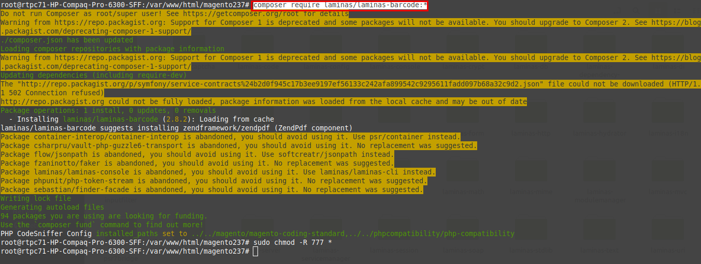

Step 2: Download the extension and unzip it.

Step 3: Upload it to code directory in your magento installation’s app directory.
If code directory does not exists then create.

Step 4: Disable the cache under System → Cache Management.

Step 5: Enter the following at the command line:
php bin/magento setup:upgrade
php bin/magento setup:static-content:deploy

Step 6: Once you complete above steps log out and log in back to the admin
panel and switch to Stores → Configuration → Mageants → Barcode - Generator.

The module will be displayed in the admin panel.

Option 2: Magento 2 install extension manually.

Step 1: Install laminas-barcode library using below command.
( As Above Image)
( require this in magento 2.3.x or 2.4.x only )

:- composer require laminas/laminas-barcode:*

Step 2: Download the extension and unzip it.

Step 3: Upload it to code directory in your magento installation’s app directory.
If code directory does not exists then create.

Step 4: Disable the cache under System → Cache Management Edit
app/etc/config.php file and add one line code:
‘Mageants_BarcodeGenerator label’ → 1

Step 5: Disable the cache under System → Cache Management

Step 6: Once you complete above steps log out and log in back to the
admin panel and switch to Stores → Configuration → Mageants →
Mageants_BarcodeGenerator, the module will be displayed in the admin panel.

Backend example :

After Installation of Extension login to Magento admin panel to set
configuration of the extension.

Extension Configuration :

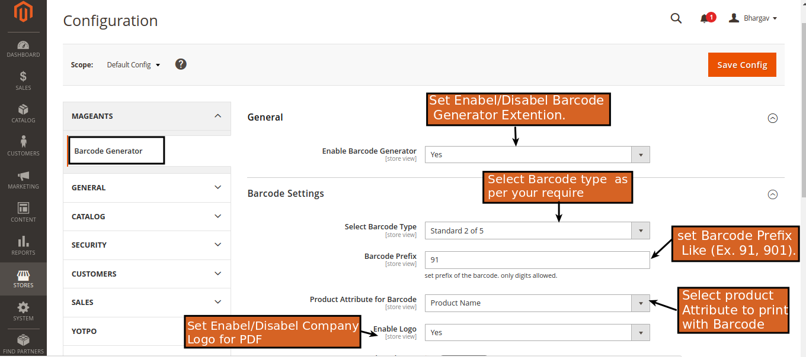
Select Barcode Type : here we have 12+ types of bar code. You can select anyone as your requirements.

Barcode Prefixe : you can add you prexies here it will print with barcode number. (ex. 91000002)

Product Attribute : you can select product attribute for pdf. It will print that attribute along with barcode image.

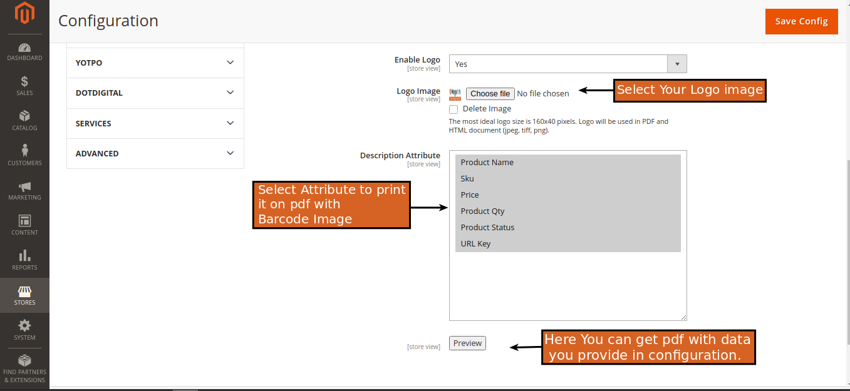

Logo : You can add/delete your logo images in pdf.

Description Attribute : you can select multiple Attribute
to print that on pdf with barcode.

Preview : on preview you’ll get sample pdf of your
configurations.

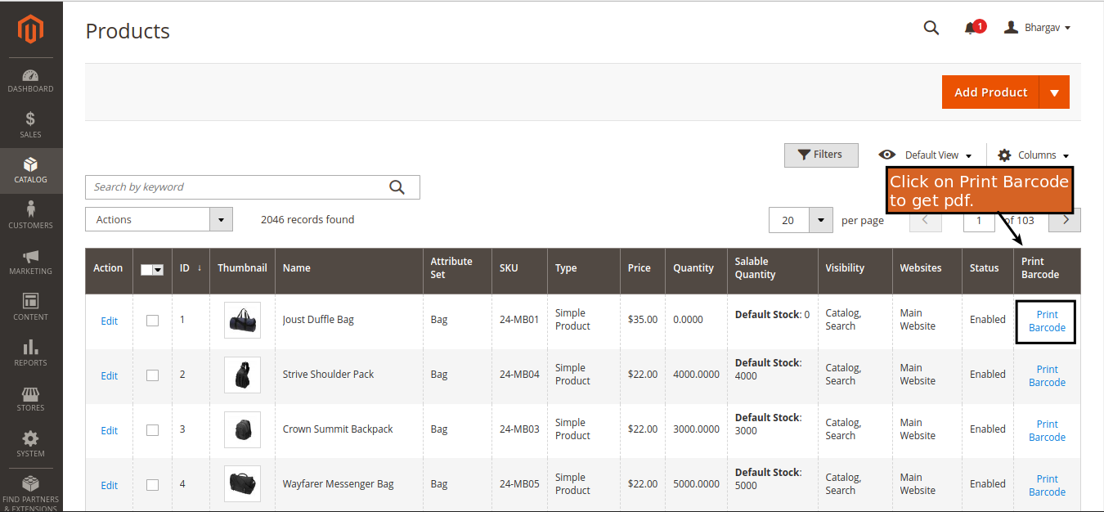

Catalog / Product : Here you get new Column in
catalog product grid page .

- you can get Barcode for particular product after click on Print Barcode.

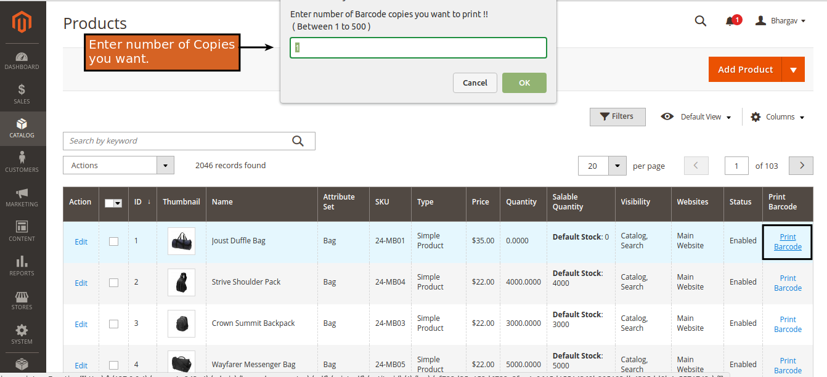

- when you click on print barcode it will ask you for
how many print you want.

- here you can get barcode copies( 1 to 500 ) in one pdf.

Sample Pdf :

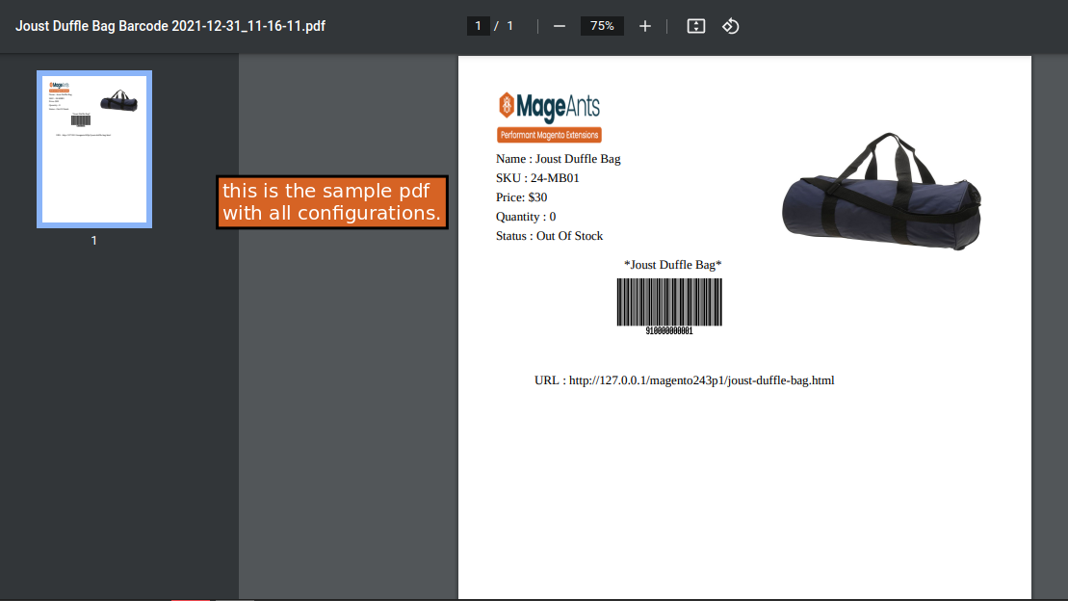

Thank you!
if you have any questions or feature suggestions, please contact us at: https://www.mageants.com/contact-us

Your feedback is absolutely welcome!

